IVY TECH COMMUNITY COLLEGE

**SDEV 140 / Introduction to Software Development**

**Software Development Project – Part 1**

# Student’s name ______________________ Section _______ Instructor’s name _________________

**INTRODUCTION**: Over the next weeks, you will be developing a small software project that includes a wide range of activities: needs analysis, screen design, algorithm development, programming, testing, debugging, documentation and publishing.

**PRELIMINARY:** You should already have accessed the free e-textbook we are using from Books 24x7 and installed/gained access to Microsoft Visual Studio Community 2015 following instructions elsewhere. If you have not done so, please backtrack and ensure that you have access to the book and software.

The last part of the lab assignment is to complete the design of the DroneDogs Order Form below by entering names for the controls on the screen form, using Hungarian Notation (sometimes called modified Hungarian Notation) as the naming convention for variables and controls.

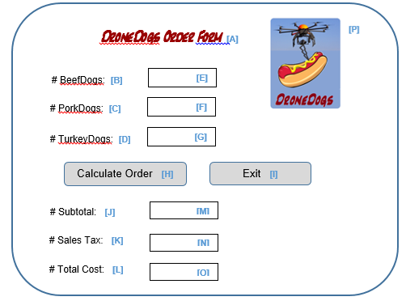

Hungarian notation uses 3 letter prefixes for all names, to indicate the types of control/variables to which they refer. The remainder of the name is a meaningful name.

Some common prefixes relevant to this assignment are as follows, and others can be easily looked up online through a search for Hungarian notation.

.

* *btn* for a button
* *lbl* for a label
* *txt* for a text box
* *img* for a picture or image

For instance, a good name for item A: in the diagram above would be lblDroneDogHeader.

Note: the DroneDogs logo is in a picture box, so you’ll want to use an appropriate name for that type of item in the assignment below.

1. Enter the control name you would assign, using Hungarian Notation:

A:

B:

C:

D:

E:

F:

G:

H:

I:

J:

K:

L:

M:

N:

O:

P:

1. Which control would you recommend have the default “focus” (the cursor is active here) when the form loads?
2. Would you design your application so that the Enter Key on the keyboard automatically worked as a click on the Calculate Order button? The Exit button? Neither? Why?